

Windows10 Enrollment

1. Introduction 2

2. Scope and Prerequisites 2

3. Migration Process 2

**3.1 Update Windows and check available space** 2

**3.2 Disconnect from CDBspace** 3

**3.3 Disable Bitlocker** 6

**3.4 Confirm Disconnection** 7

**3.5 Uninstall Beyond Trust, Forcepoint, and any version of Office and MS Teams.** 7

**3.6 Connect to the Cognizant Tenant** 11

**3.7 Set Up your Device** 13

**3.8 Set Up Windows Hello** 15

​​

# Introduction

This document illustrates and explains the process of migrating a SoftVision hybrid Azure AD joined Windows 10 device from the CDBspace (Softvision) Intune tenant to the Cognizant Intune tenant.  This process is part of the Blueprint program.

# Scope and Prerequisites

Prior to the migration, the IT team will share local admin details necessary for the migration and a checklist of tasks to complete which the user must complete and return the checklist to IT before  beginning the migration.

In addition, the user must consider the following:

* Validate access to your Softvision machine without any issues.
* Have a Softvision hybrid Azure AD joined Windows 10 device with all the apps.
* Make sure the Cognizant ID and password are noted down correctly.
* Print or open the instructions on a secondary device before starting.
* Use of an alternative device (laptop or mobile) to access Softvision Gmail (browser version at least) in order to communicate with the IT Team.

# Migration Process

### **3.1 Update Windows and check available space**

* Be sure that your Windows OS is up to date by going to the following location:

Settings -> Windows & Security -> Windows Update

* Check the C: Drive free space on your machine that there is at least 20 GB free space.

### **3.2 Disconnect from CDBspace**

* Log out of your user profile.
* Login with the local user account that is shared by the IT Team by email. Be sure to use this string:

**.\username**

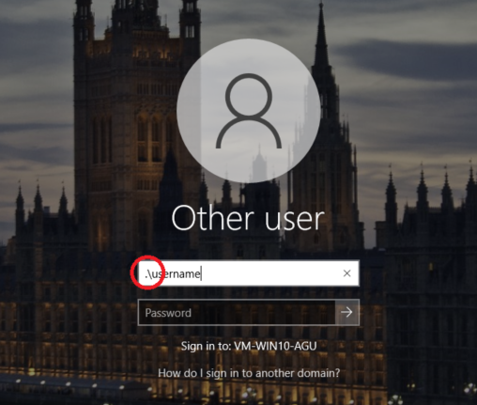

* Select Settings>Accounts>Access work or school.
* Click on Disconnect.

* Click on Yes on the next screen.

* Click on Disconnect.

* Select Restart Now.

### **3.3 Disable Bitlocker**

* Log back in with the local user account. Be sure to include this string “.\username”.
* Open This PC, right click on C: drive and then click on Manage Bitlocker

* In the next step Click on Turn off Bitlocker for the C: drive. If you have multiple drives, then you will get a pop-up to confirm to decrypt all drives, in this case click on Decrypt all Drives.

* Wait for the Decryption to be completed.

### **3.4 Confirm Disconnection**

Once the decryption is completed, the user must contact the IT department to confirm disconnection from the CDBspace is complete.  The user can use the browser version of Gmail to   contact the IT Team.  In this instance the user can use their secondary device to access Softvision email. Do not use your personal email.

The user will receive a confirmation email from the IT Team to continue.

**\*\* DO NOT proceed until you have received a notification from IT\*\***

### **3.5 Uninstall Beyond Trust, Forcepoint, and any version of Office and MS Teams.**

* Log back in with the local user account and use this string:   .\username.
* Open Control Panel > Under Programs click on Uninstall a program.
* For Beyond Trust, Uninstall Privilege Management Console Adapter and Privilege Management for Windows.

You might get a dialog box saying: “The following applications should be closed before continuing the installation”.  Please close any applications that you can and click Ignore.

* Reboot the machine
* Log back in with the local user account using the string .\username.
* Check if Forcepoint One Endpoint is present on your machine:
* Open Control Panel -> Under Programs click on Uninstall a program, and search for Forcepoint One Endpoint.

* If you have Forcepoint on your machine, then go ahead and uninstall it. **This process will ask for an uninstallation password and if it does, please contact IT.**

* After uninstallation is completed, reboot the machine.
* Next uninstall Microsoft 365 apps for enterprise or any version Microsoft Office. Note, a new version of Microsoft Office and Microsoft Teams is installed after  the migration.
* STEP1. Identify if you have MS Office or MS O365 apps Installed.

* STEP2. Uninstall by clicking and then select uninstall.

* STEP3. Click Yes to confirm.

* STEP4. Final message that the uninstall was successful.

* Please uninstall any version of Microsoft Teams.
* Follow the instructions above for uninstalling MS 365 or Office.

### **3.6 Connect to the Cognizant Tenant**

* Log back in with the local user account. Be sure to use the string “.\username”.
* Select Settings>Accounts>Access work or school.
* Click on Connect.

* On the next screen select from the **Alternate actions** section “Join this device to Azure Active Directory.”

* Enter the Cognizant credentials starting with the [*employeeid@cognizant.com*](mailto:employeeid@cognizant.com.and)*.* and complete multi-factor authentication setup if it appears.

* Select “Join” on the next screen

* Wait for the device to finish setup.

* Click on “Done” on the next screen

* Navigate to the Access work or school settings again and verify that it shows you are connected by the Cognizant ID.
* Confirm that the “Info” button appears as show in the screen shot below. **If the Info button is not there, wait for ten minutes, and after that time if it does not appear contact IT.**

### **3.7 Set Up your Device**

* Go to the Start menu>Switch user and login to the machine using your Cognizant user id.

* Press CTRL + ALT + DEL and login using your Cognizant credentials like below

If you receive the error message below, press **Try again.**

### **3.8 Set Up Windows Hello**

* Click Ok on the next screen for Windows Hello.

* Complete the Multi-Factor authentication setup and set up a PIN.

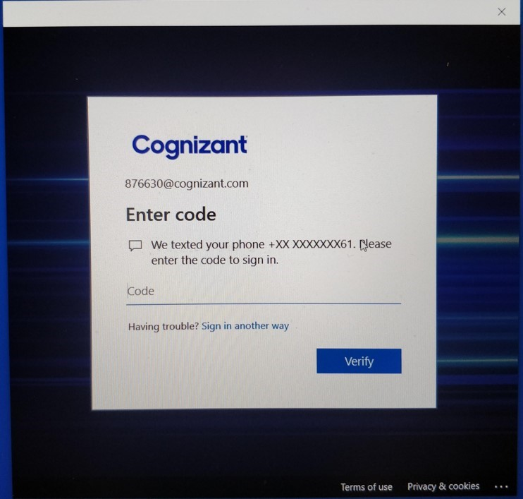

* After all set, click OK.

